OCEANA COUNTY

JUNIOR MARKET

GOAT RECORD BOOK – 2025

(for ages 5-7 years old)



As a member of the Junior Market Animal Project, you are required to submit your records as part of an educational project notebook in order to show your animal at the Oceana County Fair. This notebook must be shown to the Goat Superintendent or designated Small Market Weighmaster at the time of weigh-in and then entered by you in the Educational Notebook Division at the Oceana County Fair on Entry Day.

AGE: __________
The age you enter depends on how old you were on January 1, 2025

NUMBER OF YEARS IN PROJECT: ____________
Use this sheet as the first page of your project record book. Fill it out completely.
Please print or type neatly.

NAME ________________________________________________________________

4-H CLUB _____________________________________________________________

LEADER ______________________________________________________________

DATE RECORDS STARTED _________________ DATE ENDED _____________

JUDGE’S SCORE/COMMENT SHEET

(PLEASE DO NOT REMOVE, PLACE THIS SHEET IN SHEET PROTECTOR OR GLUE TO COVER). This sheet must be keep free to the judge to write their comments.

This sheet should help each junior market member understand their ribbon placing.

A. Specific educational value or worth

___ All questions were answered completely

___ All calculations were correct

___ Calculations were incorrect

___ Questions were not completely answered

___ Questions were not answered (missed questions)

B. Notebook contains all project records

___ Notebook contained all project records and were fully completed

___ Notebook contained additional project related information (research

materials etc.)

___ Project records were incomplete

___There was no additional project related information

C. Accuracy, neatness and general appearance

___Notebook was neat in appearance (typed/hand printed)

___ Notebook pages were clean and stain free

___Notebook pages were in order and complete

___Notebook pages were out of order and missing pages

___Notebook was difficult to read and messy

___Notebook had wrinkled and stained pages

Other Comments: ___________________________________________________________

__________________________________________________________________
2025-Jr. Market Goat Page 2

OBJECTIVES

- To let members experience love of animals.
- To members to experience the obligations and responsibility required in a livestock enterprise.
- To let members experience and cope with the “values” and “attitudes” of responsibility in a relatively unsupervised environment. Supervision will be provided on a periodic basis.
- To allow the member to provide meat for the family table and/or to experience the marketing process and system through sale of his project.
- To let the member experience competition by fitting and showing their animal at local or area organizational sponsored shows and the Fair.

This record book is part of your Junior Market Goat project. By keeping records up-to-date you will be able to see how much progress you make as you set goals and work to accomplish them. Write or type neatly and clearly. Please keep the pages in order. Feel free to add extra pages at the end of your notebook.

SCORING CRITERIA
The following breakdown will be used during the judging process of all market livestock notebooks.

A. Specific educational value or worth 30%
B. Creative way of showing what has been learned 10%
C. Notebook contains all project records 50%
D. Accuracy, neatness and general appearance 10%

The Oceana County Agricultural Society encourages parent assistance with your project and project notebook. If you should have any questions, please contact the MSU Extension Office.

If a parent or an adult helped you in filling out your notebook please have them sign below that the answers are YOUR answers and that they assisted you in the writing of the answers and the understanding of the questions only.

______________________________________________________________
(Signature of person helping with notebook)

______________________________________________________________
(Printed name of member)

2025-Jr. Market Goat Page 3

ABOUT YOUR GOAT:

My Goat’s Name: ________________________________________________

My Goat’s Breed: _________________________________________________

My Goat’s Color(s) are: ___________________________________________

My goat is a (circle one): Wether (boy) Doe (girl)

My goat’s Scrapie Tag Number ____________________________________

My goat’s 4-H Tag Number_________________________________________

My goat is dehorned (circle one): Yes No

My goat was purchased from: _____________________________________

My goat was born-Month: ___________ Year ________________________

PARTS OF A GOAT
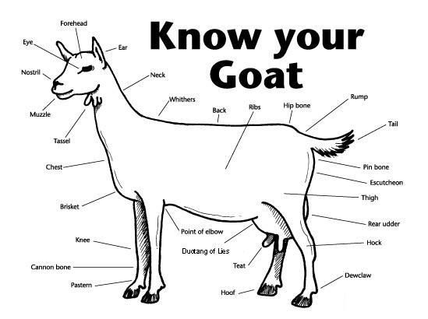
2025-Jr. Market Goat Page 4

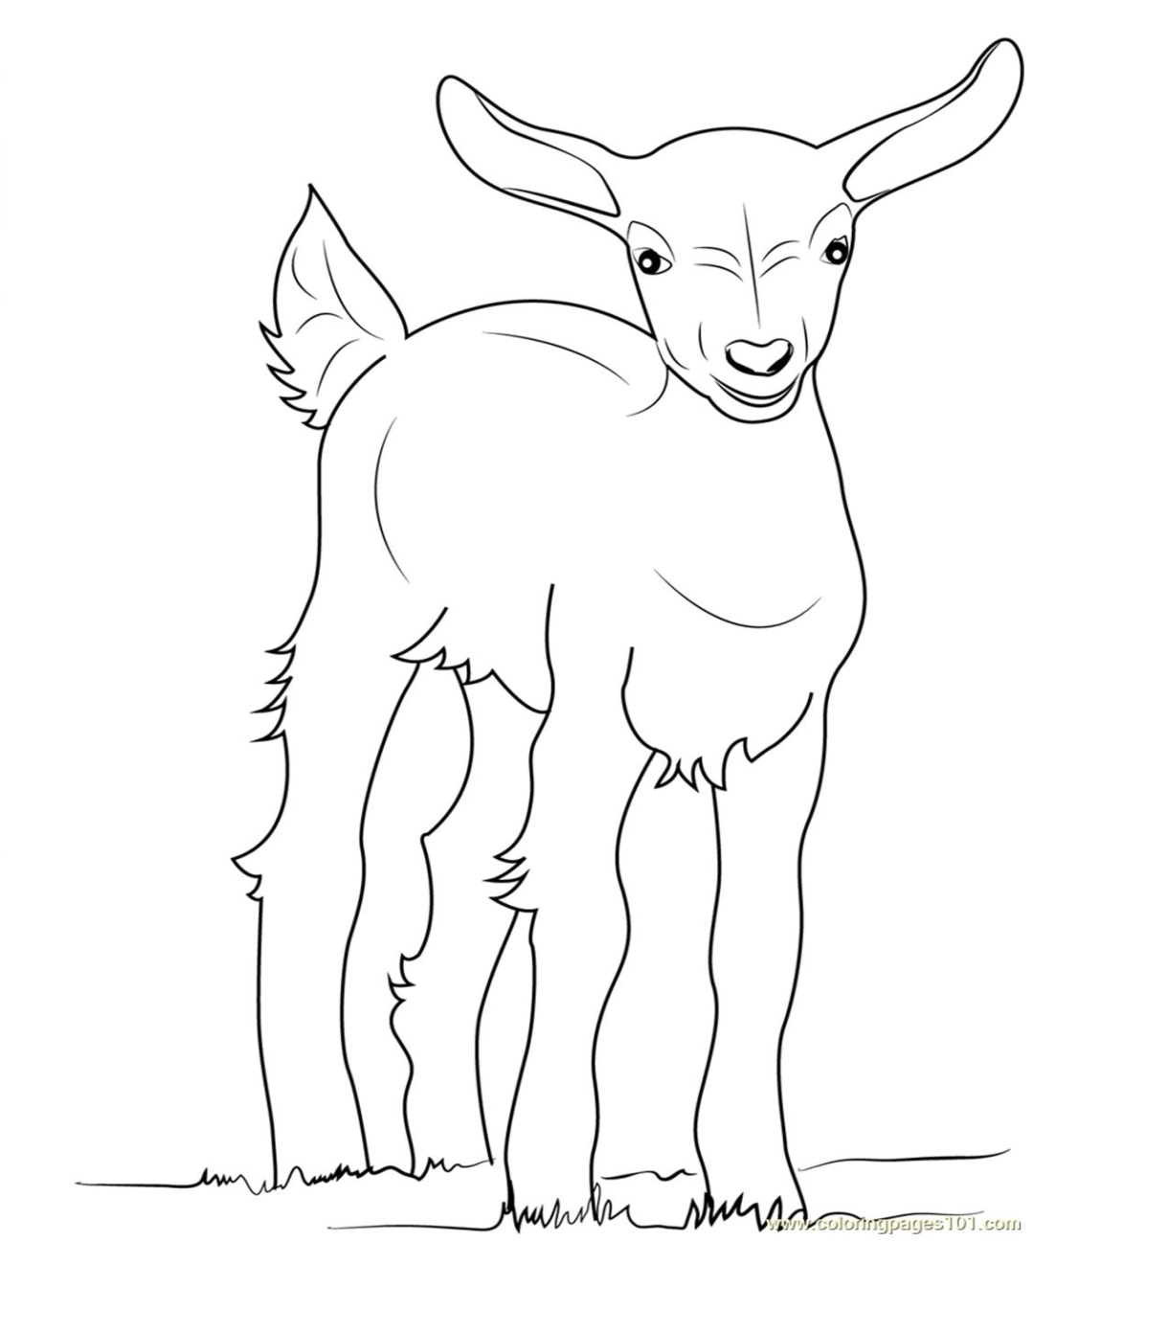
COLOR THE GOAT
TO LOOK LIKE
YOURS AND LABEL 5 PARTS OF THE GOAT, USING THE CHART ON PAGE 3

2025-Jr. Market Goat Page 5

WEIGHT CHART

(have a parent, grandparent, leader, older youth, etc. help you with the next sections)

BEGINNING WEIGHT__________ AGE_______ DATE___________

WEEK | AGE | WEIGHT

FINAL WEIGHT (FW)_____________AGE_____________DATE_____________

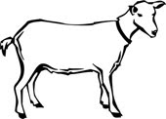

2025-JR Market Goats Page 6

EXPENSES

(A) Cost of kid $______________

DATE | LBS. OF FEED | FEED- VARIETY/TYPE | COST
 |  |  | $
 |  | (B) TOTAL SPENT ON FEED | $

DATE | OTHER EXPENSES, VET, SUPPLIES, HOUSING, MARKETING, ETC. | COST
 |  | $
 | (C) TOTAL SPENT ON OTHER EXPENSES | $

GRAND TOTAL OF ALL EXPENSES (TE): $ ____________ (TE)
(total of A,B, and C)

__________________ ÷ __________________ = ___________________________________
Total Expenses (TE) Final Weight (FW) Break Even Price (BE) (or total cost per pound to raise your animal)**

**have your parent, leader or an older teen in your club help you figure out your breakeven price (BE). The breakeven price is the price that you need to get at the Junior Market animal auction in order to not lose money on your market project**

2025-JR Market Goats Page 7

ANIMAL CARE AND MANAGEMENT
Your project requires regular care and management. List the things necessary to take care of your project animal(s).

Grain-Name of Feed/Pellet that was fed. (Glue a few pieces here too)
Hay- How much hay was fed each day? (Glue a few pieces here too)
Water- How many times a day did you check your animal’s water?
Supplements/Other (any things else given to your project? Include treats even)

2025-Jr Market Goats Page 8

PROJECT INFORMATION
Finish the Sentences

1. My goat always needs clean, fresh _______________________________ to drink.

2. When I grow up I want to be a ___________________________________________.

3. The best, or most fun, part of my project was: _____________________________ ______________________________________________________________________________ ______________________________________________________________________________
______________________________________________________________________________

4. The hardest part of my project was: _____________________________________ ______________________________________________________________________________ ______________________________________________________________________________

5. The person that helped me the most with my project was: __________________ ____________________________________________________________________________________________________________________________________________________________

6. Did you help someone with their project?
______________________________________________________________________________

______________________________________________________________________________

7. How did you treat your animal extra special?
______________________________________________________________________________

______________________________________________________________________________

______________________________________________________________________________

2025-JR Market Goat Page 9

4-H KNOWLEDGE
The 4-H Pledge- Draw a line to the picture that fills in the blank (see the example)

I pledge…
HANDS

HEALTH

HEAD

HEART

WORLD

COUNTRY

CLUB

COMMUNITY










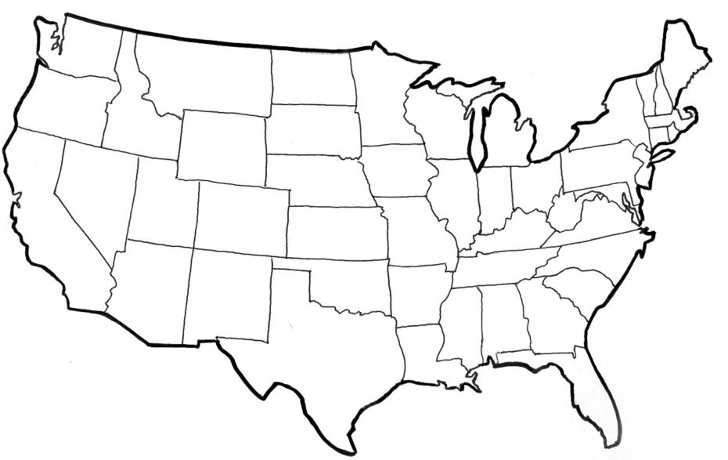





My ____________ to clearer thinking,

My ____________ to greater loyalty,

My ____________ to larger service, and

My _____________ to better living,

for my ____________________,

my _______________________,

my _______________________,

and my ____________________.

Number of club meetings held: ________ Number I attended: _________
2025-JR Market Goat Page 10

MY STORY
(Interesting things that happened to me and my animal this year, challenges, highlights of my year or ANYTHING I would like to share about my overall
experience. You can even draw a picture of you and your animals if you prefer).

POTENTIAL BUYERS NAMES

As part of your 4-H Junior Market Livestock Project, you must personally contact at least three potential buyers before the Oceana County Fair. You are encouraged to seek two new buyers that have not been asked or submitted before. You also must have at least three different buyers than those of your siblings in the market livestock project. Please confirm with your buyers their accurate mailing address (example: post office box vs. a street address). The information on page 14 must be completed and taken to the Oceana County MSU Extension Office on or before the due date where it will be copied and used to send out letters to your potential buyers. This page will remain in your notebooks. This is a Market Livestock Committee rule. Failure to comply will result in not being able to sell your animal in the 4-H Market Livestock Sale.

2025-JUNIOR MARKET GOATS Date: _______________
PAGE 11 Staff: _______________
JUNIOR MARKET/SMALL MARKET POTENTIAL BUYER’S LIST
GOAT PROJECT (AGES 5-7)

Name______________________________ Club_________________________
Please print business names and complete addresses clearly.

  - Contact Name ____________________________________________________

Business Name ____________________________________________________

Mailing Address _________________________City_________________Zip_____

Phone _______________________ After Hours Phone______________________
Mailing Preference (Please Check One): Email ____ Postal Delivery ____

Email ____________________________________________________________

Signature__________________________________________________________

2. Contact Name ____________________________________________________

Business Name ____________________________________________________

Mailing Address _________________________City_________________Zip_____

Phone _______________________ After Hours Phone______________________
Mailing Preference (Please Check One): Email ____ Postal Delivery ____

Email ____________________________________________________________

Signature__________________________________________________________

3. Contact Name ____________________________________________________

Business Name ____________________________________________________

Mailing Address _________________________City_________________Zip_____

Phone _______________________ After Hours Phone______________________
Mailing Preference (Please Check One): Email ____ Postal Delivery ____

Email ____________________________________________________________

Signature__________________________________________________________
(Must be stamped by the MSU Extension Office)

2025- JR Market Goats Page 12

PICTURES OF YOUR PROJECT

(Please use this page for your project pictures. Add additional pages if you would like. The judges appreciate you labeling the pictures so they
know what the picture shows.)

NON-CLUB POINTS- JUNIOR/SMALL MARKET PROJECT
(This must be filled out by participant before presenting for signatures at the MSUE office)
MEETING NAME | LOCATION | DATE | POINTS | SIGNATURE OF LEADER, SUPERINTENDENT OR MSU STAFF
Please note: This form must be included with your notebook and turned into the weigh master on entry day of the Fair. BEFORE SEEKING SIGNATURES AT MSU EXTENSION – MEETING NAME AND DATE MUST BE COMPLETED. You need to accumulate nine (9) points to be allowed to sell your animal. Six (6) of these nine (9) points must come from club meetings. Two (2) of these 9 points are non-club points must be earned from attending various 4-H events and activities. One (1) of these 9 points must be a fairgrounds workbee point. See your leader, the MSUE office, or online at https://www.canr.msu.edu/oceana/oceana_county_4_h/oceana_4_h_market_livestock for a listing of approved nonclub points.

JUNIOR/SMALL MARKET PROJECT CLUB POINTS
(This must be filled out by participant before presenting for signatures at the MSUE office)
MEETING NAME | LOCATION | DATE | POINTS | SIGNATURE OF LEADER, SUPERINTENDENT OR MSU STAFF

Please note: This form must be included with your notebook and turned into the weigh master on entry day of the Fair. BEFORE SEEKING SIGNATURES AT MSU EXTENSION – MEETING NAME AND DATE MUST BE COMPLETED. You need to accumulate nine (9) points to be allowed to sell your animal. Six (6) of these nine (9) points must come from club meetings. Two (2) of these 9 points are non-club points must be earned from attending various 4-H events and activities. One (1) of these 9 points must be a fairgrounds workbee point.

